# How to Install RemoteStaff Screen Capture (RSSC) for Mac Users

1. First You needs to configure “Security and Privacy” settings on your Mac machine before downloading the RemoteStaff Screen Capture (RSSC) installer.
   1. Go to System Preference it can be accessible under your Launchpad or Dock, please see image below.

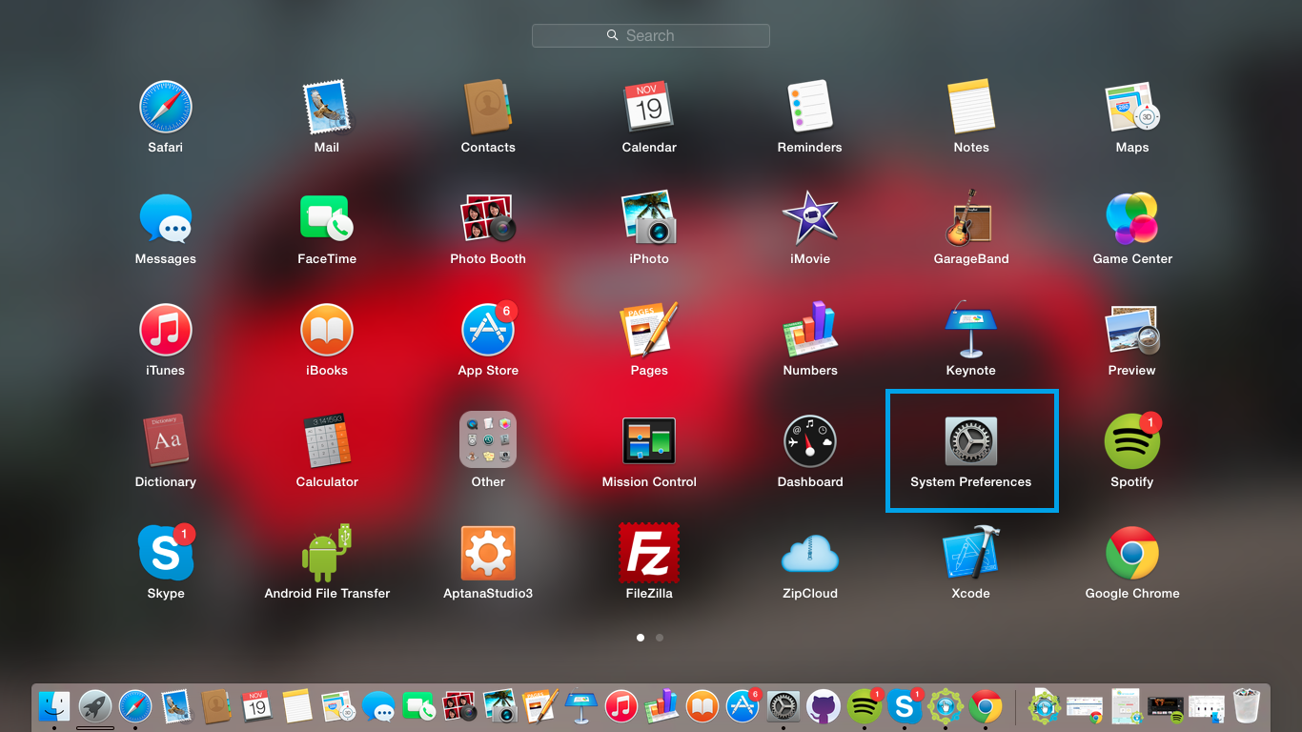

* 1. On the System Preference window, Go to Security and Privacy, click on the General Tab under "Allow apps downloaded from" select “Anywhere”. This is to allow the RemoteStaff Screen Capture (RSSC) apps to download.

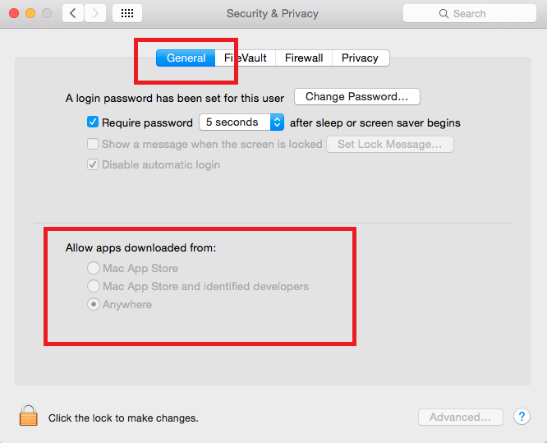

1. After configuring your “Security and Privacy” you can start downloading the RemoteStaff Screen Capture (RSSC) apps from subcon portal. Select RemoteStaff Screen Capture (RSSC) installer for Mac user → Lion/Mavericks/Yosemite/El Capitan. Kindly refer to image below

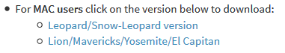

1. For RemoteStaff Screen Capture (RSSC) **screenshots capturing** Go to System Preference it can be accessible under your Launchpad or Dock , select Security and Privacy => Privacy => Accessibility then click on the + button and then locate Remote Staff Monitor
2. **Note for Mac Users with OS lower than Snow Leopard** You can run RemoteStaff Screen Capture (RSSC) via WINE but its hit and miss. RemoteStaff Screen Capture (RSSC) would run but at times, screen shots are all black. Please upgrade your OS the ASAP.